**Object Oriented Development**

Module 13 : Mutable & Immutable Classes

© FDM Group Ltd 2020. All Rights Reserved.

Any unauthorised reproduction or distribution in part  
or in whole will constitute an infringement of copyright.

|  |  |  |  |
| --- | --- | --- | --- |
| Version | Date | Author | Comments |
| 1.0 | 3 / 11 / 20 | Nick Lawton | First draft |
|  |  |  |  |
|  |  |  |  |
|  |  |  |  |
|  |  |  |  |
|  |  |  |  |

## Part 1 – Creating mutable classes

1. Create a package called immutableClassesExercise.
2. Create the Trainer and Trainee classes shown in the UML below. These classes will be mutable.
3. Create getters and setters for all attributes of Trainee
4. Create getters and setters for the name attribute of Trainer.
5. Create the addStream method for Trainer. This should add the String argument to the streamsTaught ArrayList.
6. Create the getAllStreams() method for Trainer. This should return the streamsTaught ArrayList.

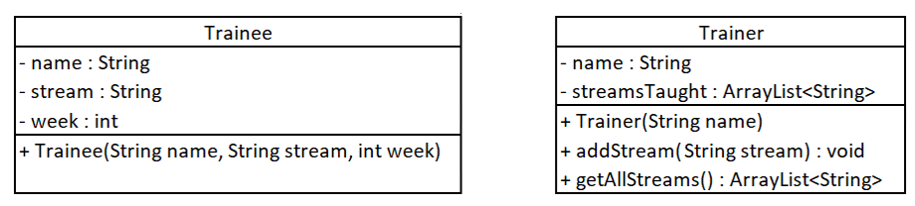

## Part 2 – Creating an immutable class

1. Create the immutable class CompletedClass shown in the UML below. Create getters and setters for all variables.
2. Ensure that the final keyword is used where appropriate and that mutable objects are cloned in the constructor and in getter methods.

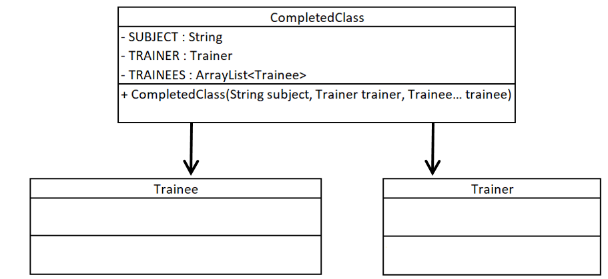

## Part 3 – Verifying immutability

1. Create 3 Trainee objects using values of your choice.
2. Create an ArrayList of Trainee objects and add the 3 trainee objects to it.
3. Create a Trainer object giving them a name of your choice.
4. Call the Trainer’s addStream() method 3 times to pass in the names of 3 different streams.
5. Create a CompletedClass object passing a String containing a course name, your trainer object and your trainee list into its constructor.
6. Change the value of the week attribute for each of your Trainee objects.
7. Call the getTrainees() method of your CompletedClass object. Loop through the returned ArrayList of Trainees and verify that the week attribute for each of the trainees has *not* been changed.
8. Call the Trainer’s addStream() method and add the name of a new stream.
9. Call the getTrainer() method of your CompletedClass object. Call the getAllStreams() method on the Trainer object that’s returned. Verify that this still contains only 3 streams.